Notes on Lilli QA/QC for Catchment metabolism project
Notes below by Jen Klug on 2/16/16
Files generated by Jen Klug and formatted and QA/QC’s according to the Catchment metabolism Data request form
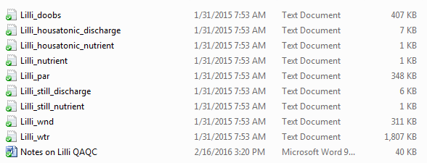
METADATA
Lilli DO sensor depth = 1 m.
atmPres <- #average atmospheric pressure at local elevation, mmHg
windHeight <- 3.5 #height above lake at which wind speed is meaured
timeStep <- 15 #number of minutes between DO measurements
lat<- 41.47806 #latitude of Lilli

Missing wind speed and par from 8/31/14 16:45 to 9/24/14 16:00
Added wind speed and short wave from NLDAS data to folder. Wind speed already corrected for 10 m.

